**BLA DEED**

1. **The account been flaged under GROUP CODES** – this indicated that what you correctly have might be a 2nd BLA to the original. OR this is a correction that Ser Dept is waiting on for re-record. You will still need this deeds to be saved to the BLA folder for Seg dept to review this. Do Not Transfer.   
   
2. On the Deed this might be mentioned.
   1. “Cert” under excise stamp
   2. In the Title or in the BODY will have “BOUNDARY LINE ADJUSTMENT” wording.

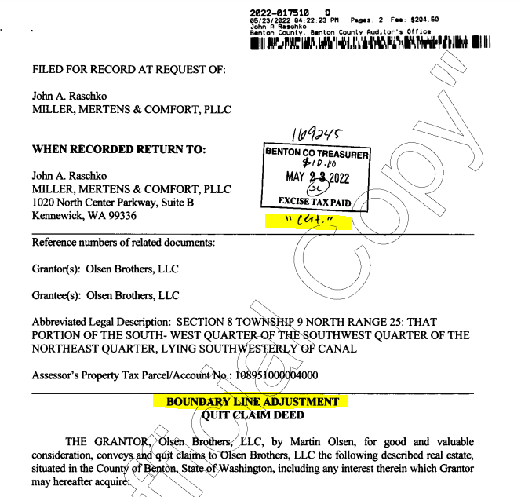

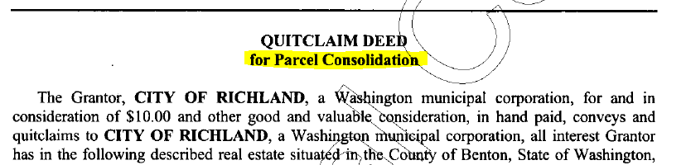

Few Samples below of how it will be worded in the body.

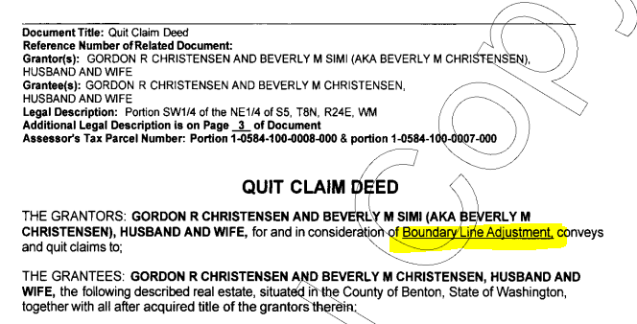

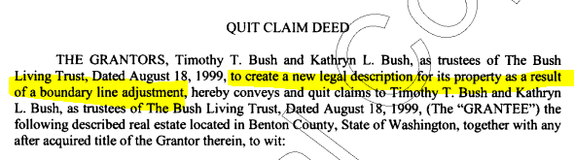

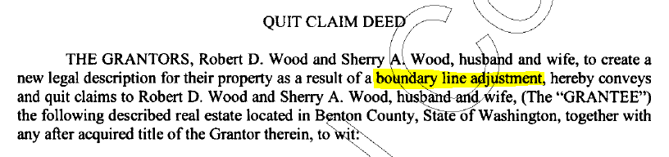

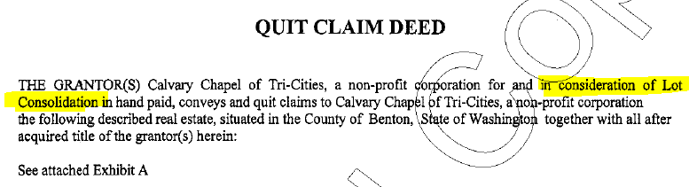

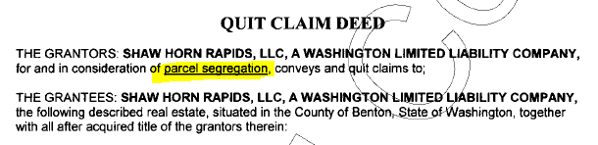

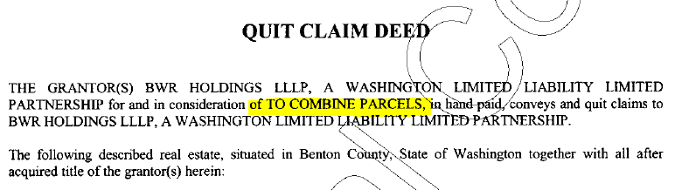

1. When you open an **EXCISE** to verify mailing address…. In SECTION 7 – it will say “BOUNDARY LINE ADJUSTMENT”

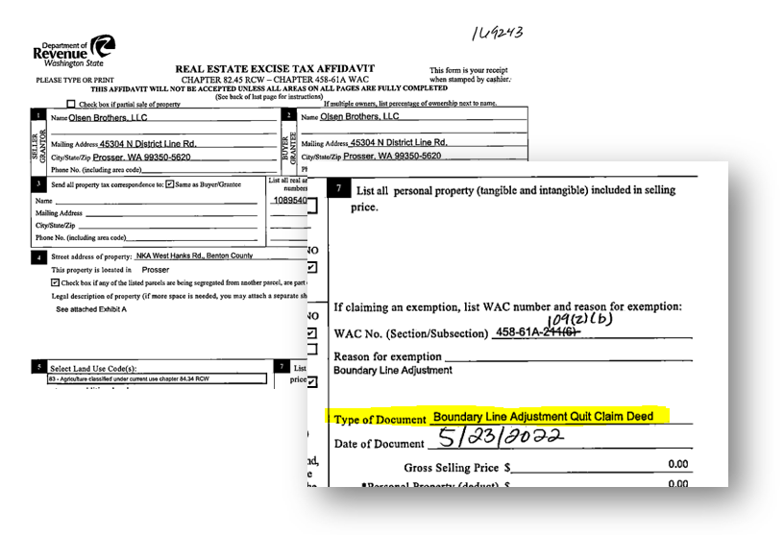

1. Parcel Number will have (IOP)Including Other Parcels, (PTN), or Parent – for a new plat.







1. The **LEGAL DESCRIPTION** **WILL NOT MATCH. THAT WILL BE YOUR MAIN INDICATION.**

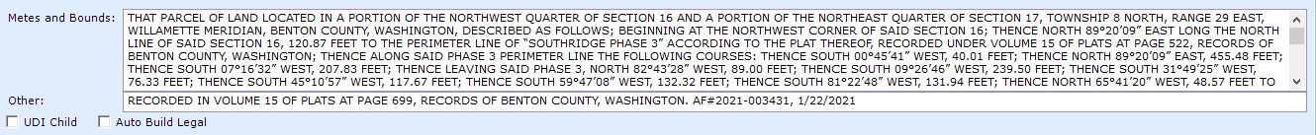

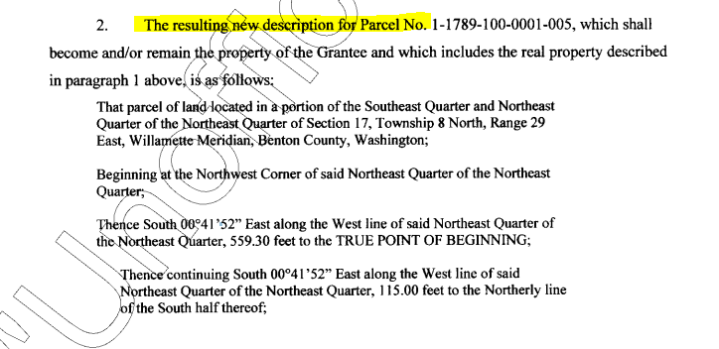

1. There will be a Treasures’ Certification for Real Property Form Attached at the end of each deed (but not all the time), stating that all taxes been paid for the year.

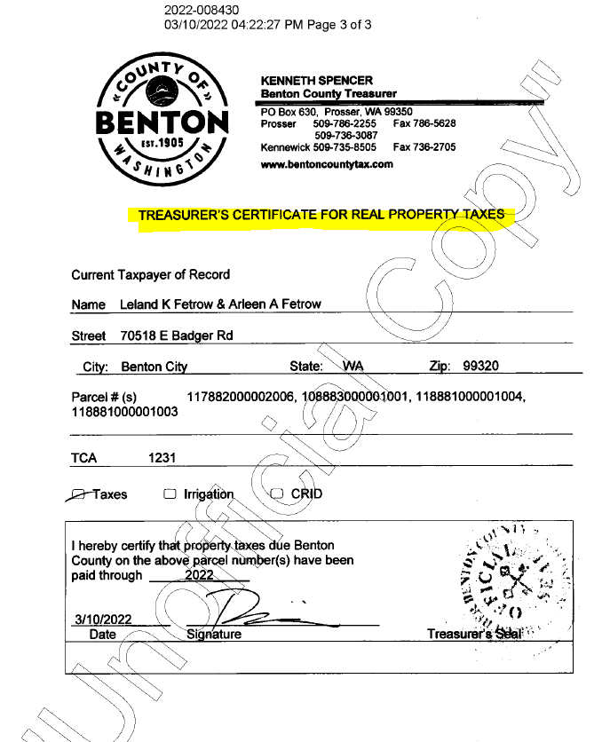

1. There is usually multiple deeds recorded in the a row between two owners or same owners. ALL the deeds need to be combined into one document and saved in BLA folder G:Clerical/Deed Technician/BLA
2. 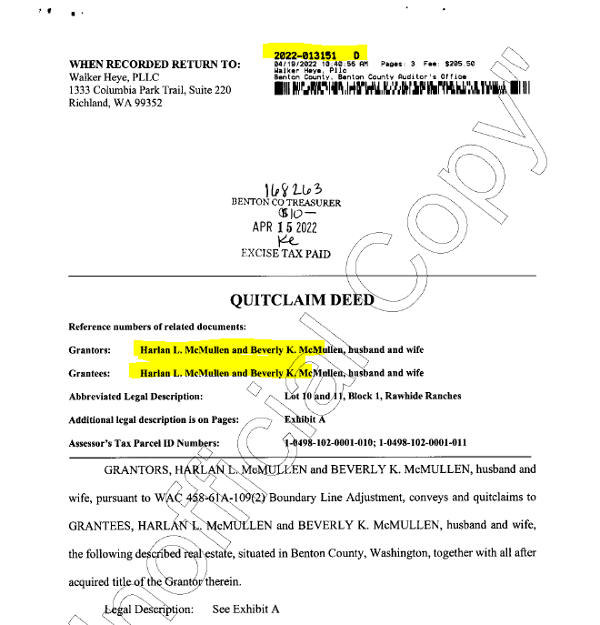
3. 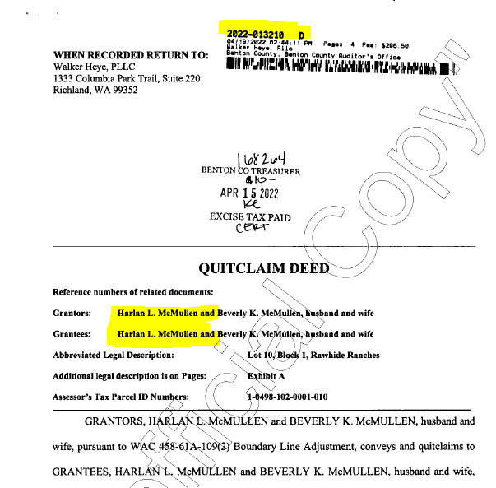
4. 